AIR QUALITY MONTIORING SYSTEM

# IOT_PHASE:4(DEVELOPMENT PART 2)

mport java.io.*; import java.net.*; import java.util.Date;

public class AirQualityMonitor {

public static void main(String[] args) { int port = 8080; // Change to the appropriate port

try {

ServerSocket serverSocket = new ServerSocket(port);

System.out.println("Air Quality Monitoring Server is running on port " + port);

while (true) {

Socket clientSocket = serverSocket.accept();

System.out.println("Client connected from: " + clientSocket.getInetAddress());

// Handle client data (Assuming sensor data is sent as text)

BufferedReader reader = new BufferedReader(new InputStreamReader(clientSocket.getInputStream()));

String sensorData = reader.readLine();

System.out.println("Received data: " + sensorData);

// You can parse and process the sensor data here

// For simplicity, let's just log the data to a file logDataToFile(sensorData);

clientSocket.close();

}

} catch (IOException e) {

e.printStackTrace();

}

}

private static void logDataToFile(String data) {

try {

PrintWriter writer = new PrintWriter(new FileWriter("air_quality_data.txt", true)); writer.println(new Date() + ": " + data); writer.close(); } catch (IOException e) {

e.printStackTrace();

}

}

}

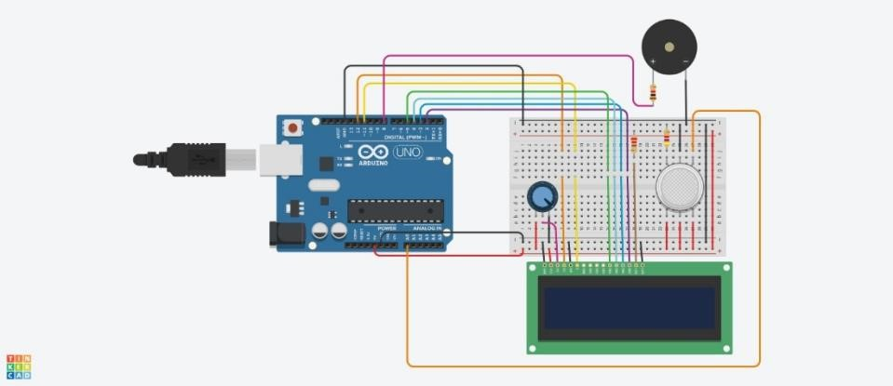

mport java.io.*; import java.net.*; import java.util.Date;

public class AirQualityMonitor {

public static void main(String[] args) { int port = 8080; // Change to the appropriate port

try {

ServerSocket serverSocket = new ServerSocket(port);

System.out.println("Air Quality Monitoring Server is running on port " + port);

while (true) {

Socket clientSocket = serverSocket.accept();

System.out.println("Client connected from: " + clientSocket.getInetAddress()); // Handle client data (Assuming sensor data is sent as text)

BufferedReader reader = new BufferedReader(new InputStreamReader(clientSocket.getInputStream()));

String sensorData = reader.readLine();

System.out.println("Received data: " + sensorData);

// You can parse and process the sensor data here

// For simplicity, let's just log the data to a file logDataToFile(sensorData);

clientSocket.close();

}

} catch (IOException e) {

e.printStackTrace();

}

}

private static void logDataToFile(String data) {

try {

PrintWriter writer = new PrintWriter(new FileWriter("air_quality_data.txt", true)); writer.println(new Date() + ": " + data); writer.close(); } catch (IOException e) {

e.printStackTrace();

}

}

}

<!DOCTYPE html>

<html>

<head>

<title>Air Quality Monitor</title>

</head>

<body>

<h1>Air Quality Monitoring System</h1>

<p>CO2 Level: <span id="co2Level">Loading...</span> ppm</p>

<p>PM2.5 Level: <span id="pm25Level">Loading...</span> µg/m³</p>

<script>

// JavaScript code to fetch data from the server and update the HTML function updateAirQuality() {

// Use AJAX, Fetch, or other methods to get data from the server

// Update the values inside the span elements with real-time data

}

// Call the function to update the data at regular intervals setInterval(updateAirQuality, 5000); // Update every 5 seconds

</script>

</body>

</html>